**TEORI VISI KOMPUTER DAN PENGOLAHAN CITRA**

**S2 TEKNIK INFOMATIKA DAN KOMPUTER**

**Image Segmentation**



Kelompok 2

Catoer Ryando 1122800012

Prihantono 1122800017

Wilhan Jechovanda Susanto 1122800018

Nur Rizky Romadhon 1223800002

**Teknik Informatika dan Komputer Politeknik Elektronika Negeri Surabaya**

**2023**

Praktikum Pertemuan 10Image Segmentation

1. **Background Subtraction**

|  |
| --- |
| *# Python code for Background subtraction using OpenCV*  import numpy as np  import cv2  cap = cv2.VideoCapture('videos.mp4')  fgbg = cv2.createBackgroundSubtractorMOG2()  while(1):      ret, frame = cap.read()      fgmask = fgbg.apply(frame)      cv2.imshow('fgmask', fgmask)      cv2.imshow('frame',frame )      k = cv2.waitKey(30) & 0xff      if k == 27:          break  cap.release()  cv2.destroyAllWindows() |

**Output :**

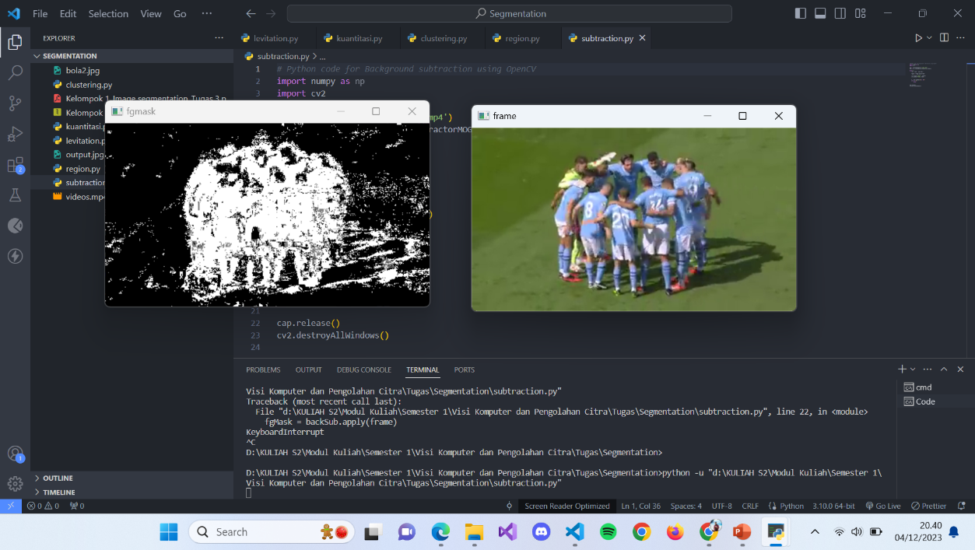

1. **Levitation**

|  |
| --- |
| *# contoh simulasi*  import pygame  import sys  pygame.init()  width, height = 400, 300  screen = pygame.display.set_mode((width, height))  bg_color = (0, 162, 92)  x, y = width // 2, height // 2  object_radius = 20  x_speed, y_speed = 1, 1  while True:      for event in pygame.event.get():          if event.type == pygame.QUIT:              pygame.quit()              sys.exit()      x += x_speed      y += y_speed      screen.fill(bg_color)      pygame.draw.circle(screen, (0, 0, 0), (x, y), object_radius)      pygame.display.flip()      pygame.time.delay(10) |

**Output :**

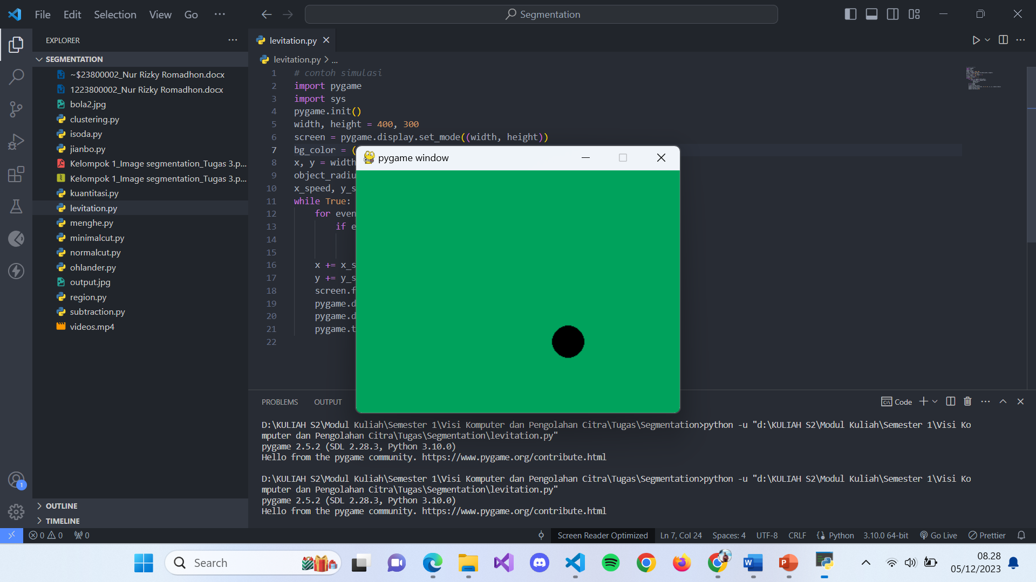

1. **Image Kuantisasi**

|  |
| --- |
| from PIL import Image  def quantize_image(input_image_path, output_image_path,num_colors):      gambar = Image.open(input_image_path)      quantized = gambar.convert("P", palette=Image.ADAPTIVE,colors=num_colors)      quantized = quantized.convert("RGB")      quantized.save(output_image_path, format="JPEG")  if __name__ == "__main__":      input_image_path = "bola2.jpg"      output_image_path = "output.jpg"      num_colors = 16      quantize_image(input_image_path, output_image_path,num_colors) |

Input :

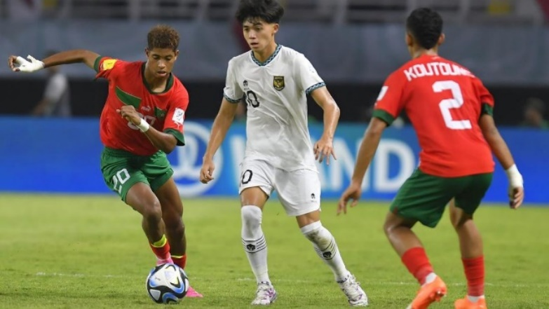

|  |  |
| --- | --- |
| num_color = 2 |  |
| num_color = 4 |  |
| num_color = 16 |  |
| num_color = 256 |  |

1. **Region Growing**

|  |
| --- |
| import cv2  import itertools  import numpy as np  import random  import sys  *#class pour une pile*  class Stack():      def __init__(self):          self.item = []          self.obj=[]      def push(self, value):          self.item.append(value)      def pop(self):          return self.item.pop()      def size(self):          return len(self.item)      def isEmpty(self):          return self.size() == 0      def clear(self):          self.item = []  class regionGrow():        def __init__(self,im_path,th):          self.readImage(im_path)          self.h, self.w,_ =  self.im.shape          self.passedBy = np.zeros((self.h,self.w), np.double)          self.currentRegion = 0          self.iterations=0          self.SEGS=np.zeros((self.h,self.w,3), dtype='uint8')          self.stack = Stack()          self.thresh=float(th)      def readImage(self, img_path):          self.im = cv2.imread(img_path,1).astype('int')        def getNeighbour(self, x0, y0):          return [              (x, y)              for i, j in itertools.product((-1, 0, 1), repeat=2)              if (i, j) != (0, 0) and self.boundaries(x := x0 + i, y := y0 + j)          ]        def create_seeds(self):          return [              [self.h/2,self.w/2],              [self.h/3,self.w/3],[2*self.h/3,self.w/3],[self.h/3-10,self.w/3],              [self.h/3,2*self.w/3],[2*self.h/3,2*self.w/3],[self.h/3-10,2*self.w/3],              [self.h/3,self.w-10],[2*self.h/3,self.w-10],[self.h/3-10,self.w-10]                      ]      def ApplyRegionGrow(self, cv_display = True):          randomseeds = self.create_seeds()          np.random.shuffle(randomseeds)          for x0 in range (self.h):              for y0 in range (self.w):                  if self.passedBy[x0,y0] == 0 : *#and (np.all(self.im[x0,y0] > 0)) :*                      self.currentRegion += 1                      self.passedBy[x0,y0] = self.currentRegion                      self.stack.push((x0,y0))                      self.prev_region_count= 0                      while not self.stack.isEmpty():                          x,y = self.stack.pop()                          self.BFS(x,y)                          self.iterations+=1                      if self.PassedAll():                          break                      if self.prev_region_count< 8*8 :                         x0, y0 = self.reset_region(x0, y0)                if self.iterations>200000:              print("Max Iterations")          print(f"Iterations : {str(self.iterations)}")          if cv_display:              [self.color_pixel(i,j) for i, j in itertools.product(range(self.h), range (self.w))]              self.display()      def reset_region(self, x0, y0):          self.passedBy[self.passedBy==self.currentRegion] = 0          x0=random.randint(x0-4,x0+4)          y0=random.randint(y0-4,y0+4)          x0 = np.clip(x0, 0, self.h - 1)          y0 = np.clip(y0, 0, self.w - 1)          self.currentRegion-=1          return x0, y0      def color_pixel(self, i, j):          val = self.passedBy[i][j]          self.SEGS[i][j] = (255, 255, 255) if (val==0) else (val*35, val*90, val*30)      def display(self):          cv2.imshow("",self.SEGS)          cv2.waitKey(0)          cv2.destroyAllWindows()      def BFS(self, x0,y0):          regionNum = self.passedBy[x0,y0]            elems = [np.mean(self.im[x0, y0])]          var=self.thresh          neighbours=self.getNeighbour(x0,y0)          for x,y in neighbours:              if self.passedBy[x,y] == 0 and self.distance(x,y,x0,y0) < var:                  if self.PassedAll():                      break                  self.passedBy[x,y] = regionNum                  self.stack.push((x,y))                  elems.append(np.mean(self.im[x,y]))                  var=np.var(elems)                  self.prev_region_count+=1              var=max(var,self.thresh)            def PassedAll(self, max_iteration = 200000):            return self.iterations > max_iteration or np.all(self.passedBy > 0)      def boundaries(self, x,y):          return  0<=x<self.h and 0<=y<self.w        def distance(self,x,y,x0,y0):          return np.linalg.norm(self.im[x0, y0] - self.im[x, y])    exemple = regionGrow(sys.argv[1],sys.argv[2])  exemple.ApplyRegionGrow() |

Input :

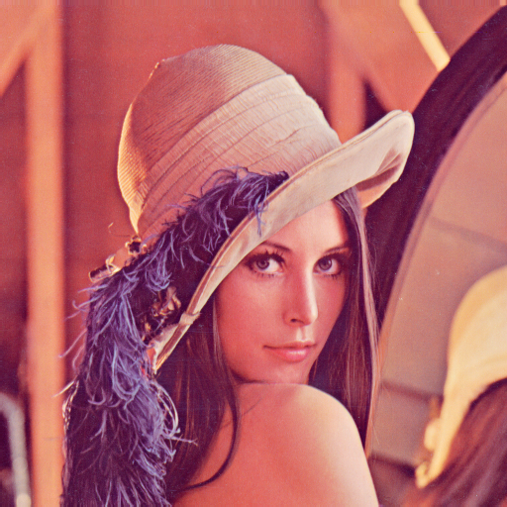



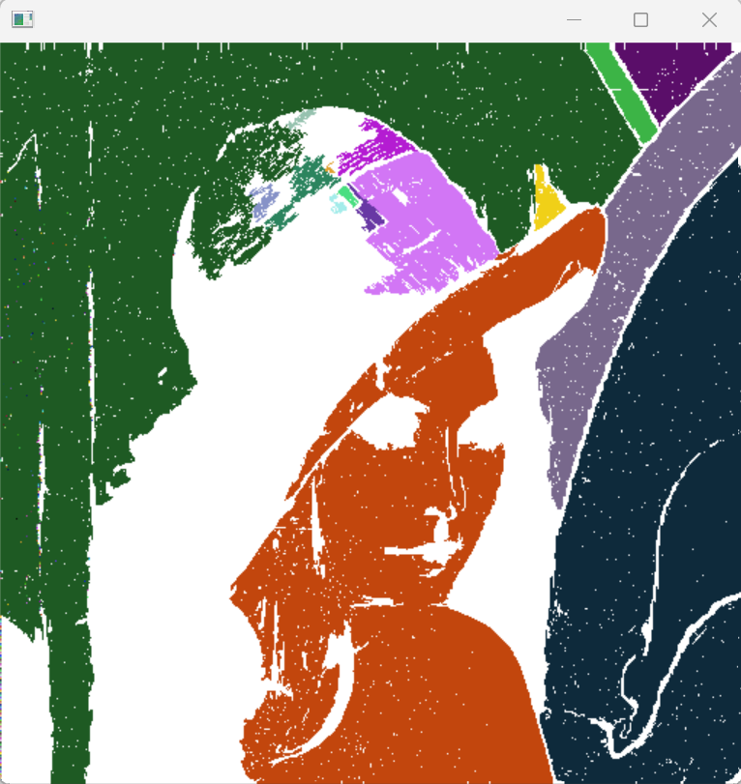

1. **Clustering**

|  |
| --- |
| *# Loading required libraries*  import numpy as np  import matplotlib.pyplot as plt  import cv2  *# load image from images directory*  image = cv2.imread('Lenna.png')  *# Change color to RGB (from BGR)*  image = cv2.cvtColor(image, cv2.COLOR_BGR2RGB)  *# Reshaping the image into a 2D array of pixels and 3 color values (RGB)*  pixel_vals = image.reshape((-1,3)) *# numpy reshape operation -1 unspecified*  *# Convert to float type only for supporting cv2.kmean*  pixel_vals = np.float32(pixel_vals)  *#criteria*  criteria = (cv2.TERM_CRITERIA_EPS + cv2.TERM_CRITERIA_MAX_ITER, 100, 0.85)    *# Choosing number of cluster*  k = 5  retval, labels, centers = cv2.kmeans(pixel_vals, k, None, criteria, 10, cv2.KMEANS_RANDOM_CENTERS)    *# convert data into 8-bit values*  centers = np.uint8(centers)  segmented_data = centers[labels.flatten()] *# Mapping labels to center points( RGB Value)*  *# reshape data into the original image dimensions*  segmented_image = segmented_data.reshape((image.shape))    cv2.imshow('res2',segmented_image)  plt.imshow(segmented_image)  cv2.waitKey(0)  cv2.destroyAllWindows() |

**Input : Output :**

 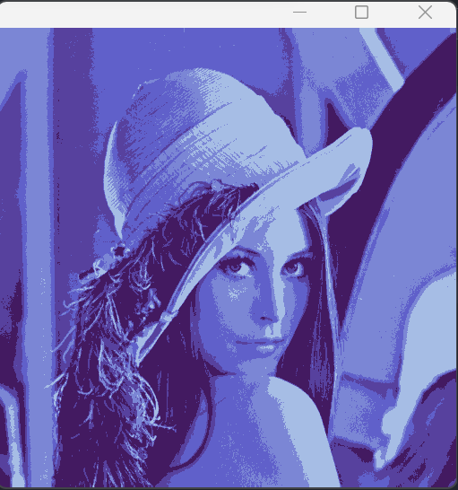

1. **Meng-Hee Heng’s K-Means**

|  |
| --- |
| import cv2  import numpy as np  from sklearn.cluster import KMeans  from skimage import feature  import matplotlib.pyplot as plt  *# Load an image (replace 'your_image.jpg' with the actual image file)*  image_path = 'bola2.jpg'  image = cv2.imread(image_path, cv2.IMREAD_GRAYSCALE)  *# Extract Local Binary Pattern (LBP) features*  radius = 3  n_points = 8 * radius  lbp_features = feature.local_binary_pattern(image, n_points, radius, method="uniform")  *# Reshape the LBP features to a 1D array*  lbp_features_1d = lbp_features.flatten()  *# Reshape the image to a 1D array for clustering*  image_1d = image.flatten()  *# Concatenate LBP features with pixel values*  data = np.column_stack((image_1d, lbp_features_1d))  *# Apply K-Means clustering*  num_clusters = 3  *# Adjust the number of clusters as needed*  kmeans = KMeans(n_clusters=num_clusters, random_state=42)  labels = kmeans.fit_predict(data)  *# Reshape the labels to the shape of the original image*  clustered_image = labels.reshape(image.shape)  *# Display the original and clustered images*  fig, (ax1, ax2) = plt.subplots(1, 2, figsize=(12, 6))  ax1.imshow(image, cmap='gray')  ax1.set_title('Original Image')  ax2.imshow(clustered_image, cmap='viridis')  ax2.set_title('Clustered Image')  plt.show() |

**Output :**

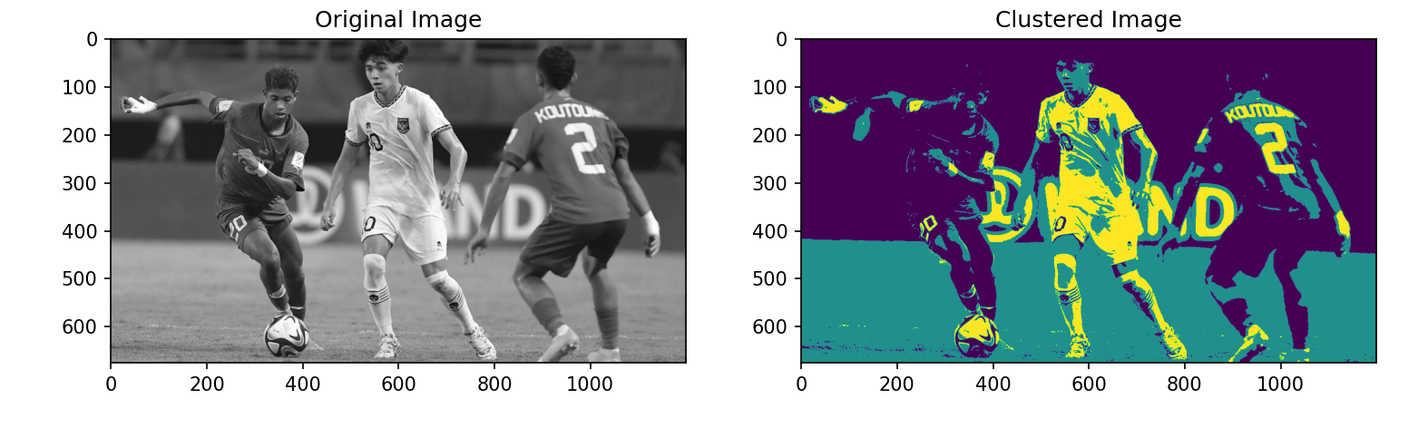

1. **Isodata Clusturing**

|  |
| --- |
| import numpy as np  import cv2  from sklearn.cluster import KMeans  *# Load an image (replace 'your_image.jpg' with the actual image file)*  image_path = 'bola2.jpg'  image = cv2.imread(image_path)  image = cv2.cvtColor(image, cv2.COLOR_BGR2RGB)  *# Reshape the image to a 2D array of pixels*  pixels = image.reshape((-1, 3))  *# Apply ISODATA clustering (K-Means with dynamic cluster adaptation)*  def isodata_clustering(data, max_clusters, min_samples=5, max_iter=100):      kmeans = KMeans(n_clusters=max_clusters, random_state=42)      kmeans.fit(data)      labels = kmeans.labels_      centers = kmeans.cluster_centers_      for _ in range(max_iter):          cluster_sizes = np.bincount(labels)          mask = cluster_sizes > min_samples          if mask.sum() == 0:              break          kmeans = KMeans(n_clusters=mask.sum(), random_state=42, init=centers[mask])          kmeans.fit(data)          labels = kmeans.labels_          centers = kmeans.cluster_centers_      return labels, centers  *# Apply ISODATA clustering*  num_clusters = 5  *# Adjust the number of clusters as needed*  isodata_labels, isodata_centers = isodata_clustering(pixels, num_clusters)  *# Replace each pixel with its corresponding cluster center*  segmented_image = isodata_centers[isodata_labels].reshape(image.shape)  *# Display the original and segmented images*  cv2.imshow('Original Image', cv2.cvtColor(image, cv2.COLOR_RGB2BGR))  cv2.imshow('Segmented Image', cv2.cvtColor(segmented_image.astype(np.uint8), cv2.COLOR_RGB2BGR))  cv2.waitKey(0)  cv2.destroyAllWindows() |

**Input :**

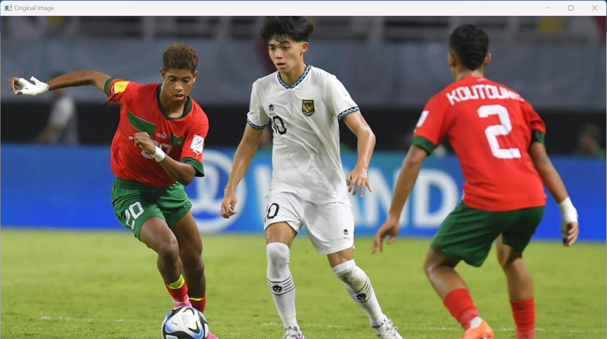

**Output :**

**K= 5**

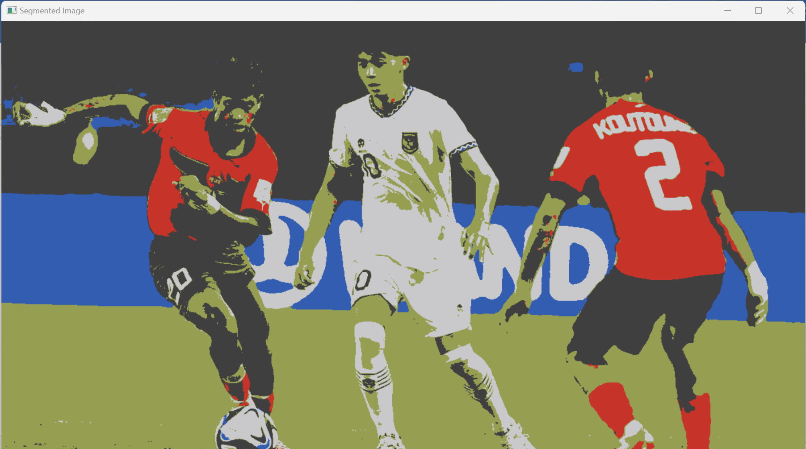

**K=6**

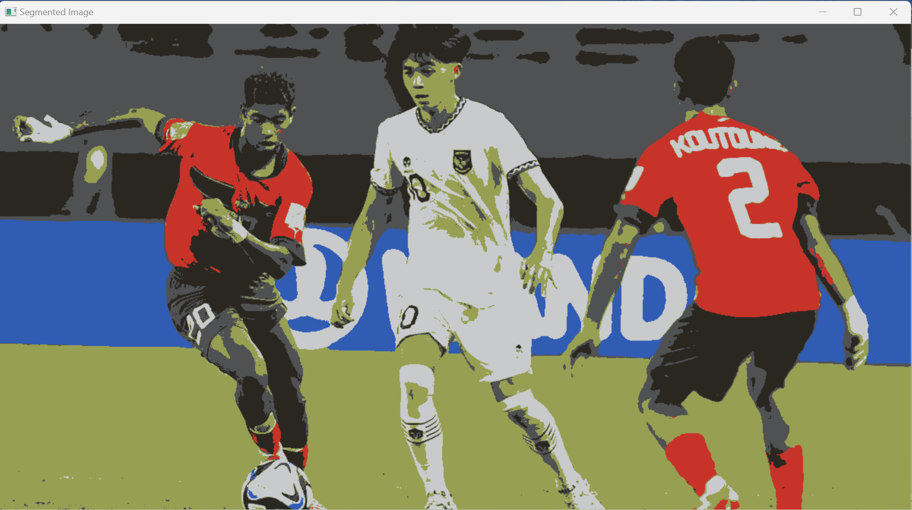

1. **Ohlander’s Recursive Histogram-Based Clustering**

|  |
| --- |
| import cv2  import numpy as np  import sys  *# Fungsi untuk melakukan segmentasi menggunakan metode Ohlander's Recursive Histogram-Based Clustering*  def ohlander_clustering(image, threshold):      if len(image.shape) > 2:          gray_image = cv2.cvtColor(image, cv2.COLOR_BGR2GRAY)      else:          gray_image = image.copy()  *# Mendapatkan histogram dari gambar*      hist = cv2.calcHist([gray_image], [0], None, [256], [0, 256])  *# Mencari nilai untuk clustering*      split_value = 0      max_val = np.max(hist)      for i in range(255, 0, -1):          if hist[i] > threshold * max_val:              split_value = i              break  *# Segmentasi gambar*      segmented_image = np.zeros_like(gray_image)      segmented_image[gray_image >= split_value] = 255      return segmented_image  input_image = cv2.imread(sys.path[0]+'/Lenna.png')  threshold_value = 0.7  segmented_image = ohlander_clustering(input_image, threshold_value)  cv2.imshow('Original Image', input_image)  cv2.imshow('Segmented Image', segmented_image)  cv2.waitKey(0)  cv2.destroyAllWindows() |

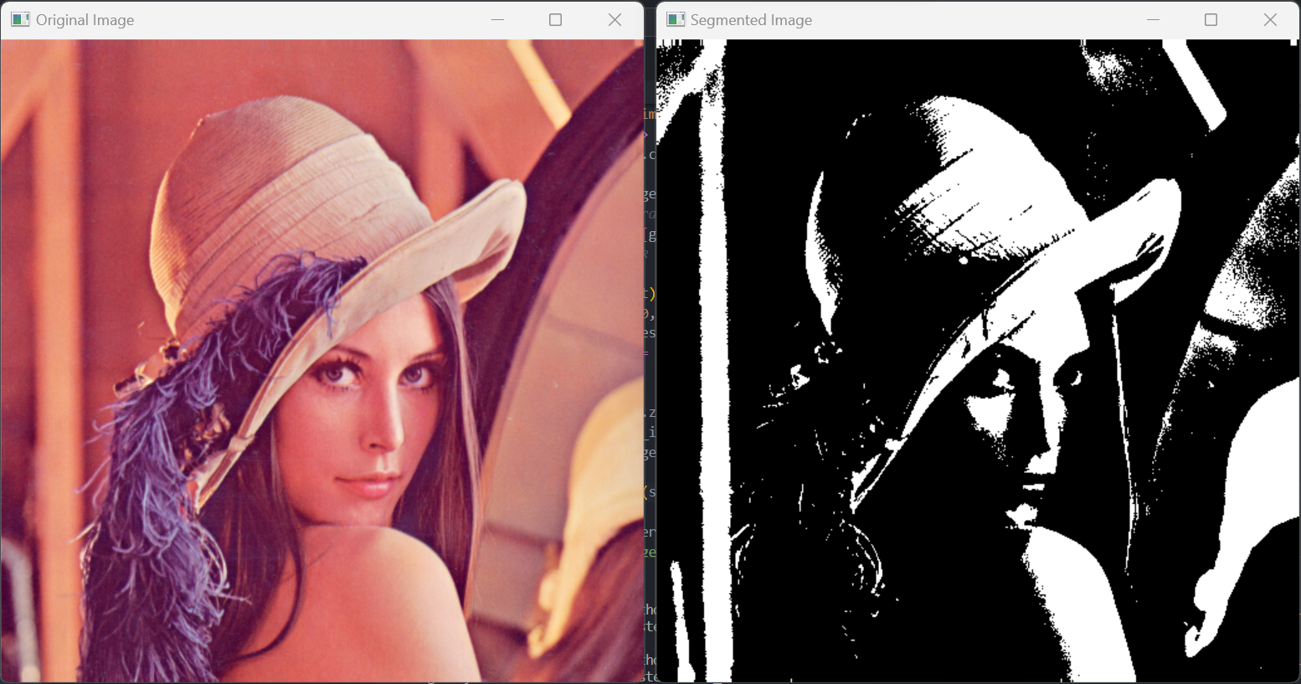

1. **Jianbo Shi’s Graph-Partitioning**

|  |
| --- |
| import numpy as np  import matplotlib.pyplot as plt  from skimage import data, segmentation, color, io  *# Load an image (replace 'your_image.jpg' with the actual image file)*  image_path = image1.jpg'  image = io.imread(image_path)  *# Convert the image to a 2D array (graph representation)*  graph = color.rgb2gray(image)  *# Apply Normalized Cut for image segmentation*  labels = segmentation.slic(image, compactness=30, n_segments=400)  segmented_image = color.label2rgb(labels, image, kind='avg')  *# Display the original and segmented images*  fig, (ax1, ax2) = plt.subplots(1, 2, figsize=(12, 6))  ax1.imshow(image)  ax1.set_title('Original Image')  ax2.imshow(segmented_image)  ax2.set_title('Segmented Image')  plt.show() |

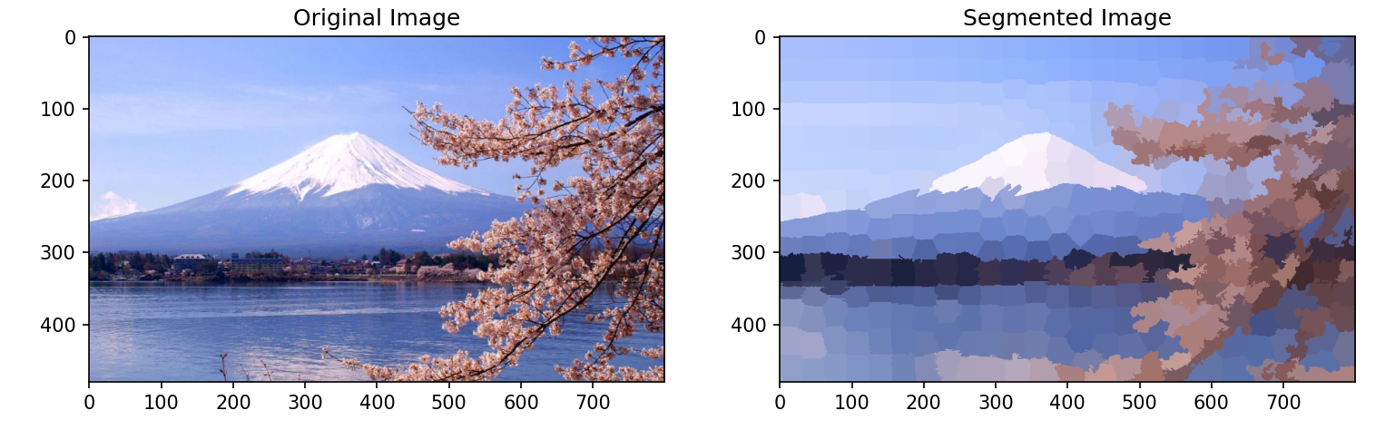

1. **Minimal Cuts**

Program berikut ini menunjukkan cara menggambar sebuah object (lines dan shapes) dan menulis (text) pada window visualisasi.

|  |
| --- |
| import numpy as np  import cv2  import matplotlib.pyplot as plt  *# Load an image (replace 'your_image.jpg' with the actual image file)*  image_path = image1.jpg'  image = cv2.imread(image_path)  image = cv2.cvtColor(image, cv2.COLOR_BGR2RGB)  *# Create a mask (0: sure background, 2: sure foreground)*  mask = np.zeros(image.shape[:2], np.uint8)  *# Define a rectangle around the object of interest (rect = (start_x, start_y, width, height))*  rect = (50, 50, 300, 200)  *# Initialize the background and foreground models*  bgd_model = np.zeros((1, 65), np.float64)  fgd_model = np.zeros((1, 65), np.float64)  *# Apply GrabCut algorithm*  cv2.grabCut(image, mask, rect, bgd_model, fgd_model, 5, cv2.GC_INIT_WITH_RECT)  *# Modify the mask to get the segmented image*  segmentation_mask = np.where((mask == 2) | (mask == 0), 0, 1).astype('uint8')  segmented_image = image * segmentation_mask[:, :, np.newaxis]  *# Display the original and segmented images*  fig, (ax1, ax2) = plt.subplots(1, 2, figsize=(12, 6))  ax1.imshow(image)  ax1.set_title('Original Image')  ax2.imshow(segmented_image)  ax2.set_title('Segmented Image')  plt.show() |

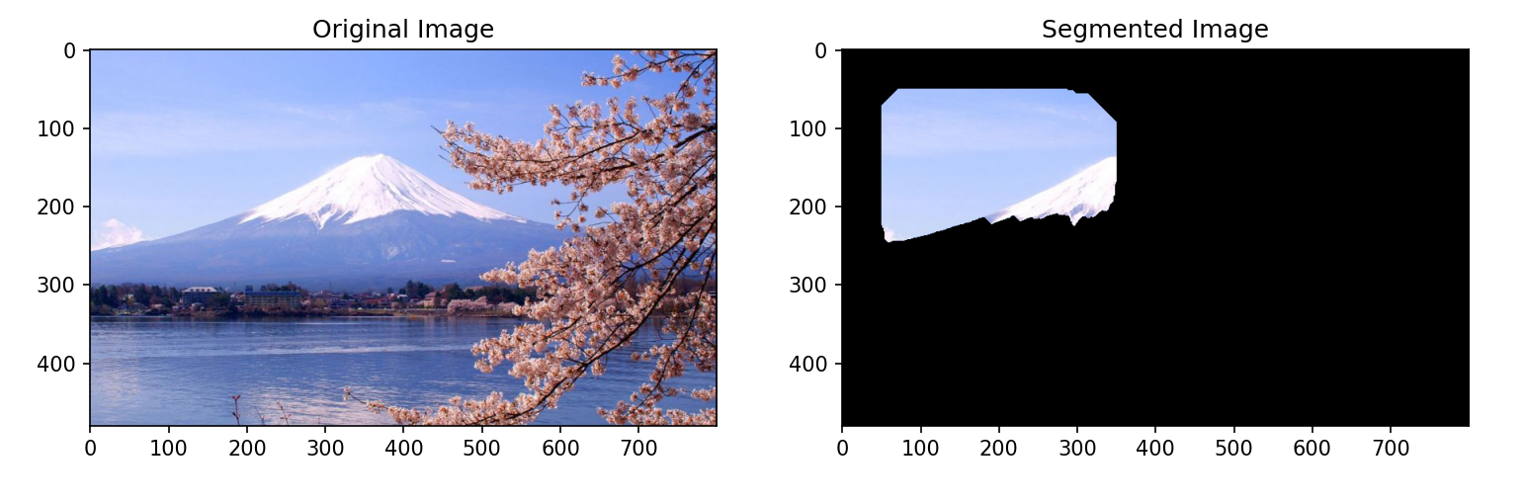

1. **Normalized Cut**

|  |
| --- |
| import numpy as np  import matplotlib.pyplot as plt  from skimage import segmentation, color, io  *# Load an image (replace 'your_image.jpg' with the actual image file)*  image_path = 'image1.jpg'  image = io.imread(image_path)  *# Convert the image to a 2D array (graph representation)*  graph = color.rgb2gray(image)  *# Apply Normalized Cut for image segmentation*  labels = segmentation.slic(image, compactness=30, n_segments=400)  segmented_image = color.label2rgb(labels, image, kind='avg')  *# Display the original and segmented images*  fig, (ax1, ax2) = plt.subplots(1, 2, figsize=(12, 6))  ax1.imshow(image)  ax1.set_title('Original Image')  ax2.imshow(segmented_image)  ax2.set_title('Segmented Image')  plt.show() |

